Chapter 19

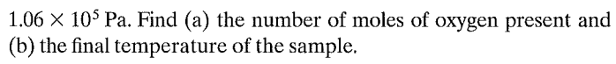

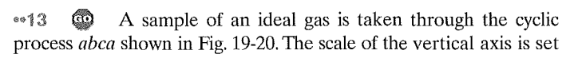

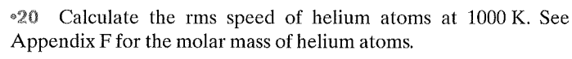

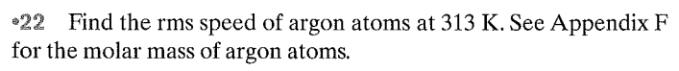

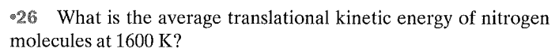

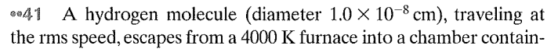

Questions

